New Directions For Internal Audit
ISBN: 0 644 38961 3
© Commonwealth of Australia,1998
Foreword
The internal audit function is undergoing a transformation in both the private and public sectors.
This has occurred by processes of renewal and re-invention through which the internal audit function has been able to maintain its relevance and responsiveness to organisational needs and priorities.
The issue of relevance is critical in a rapidly changing public sector. The demands of the financial reform program; the renewed emphasis on devolved authority and with it increased accountability for outputs and outcomes; and the challenge of contestability and market testing to both program managers and corporate support areas are examples of the forces driving change and requiring public sector entities to fundamentally re-examine their way of doing business.
The Internal Audit function is not immune from such change. The function must evaluate its continued effectiveness in terms of its relevance, its reliability and its cost.
In researching this guide many organisations indicated they had questioned the value of internal audit-a response primarily to an apparent lack of client focus and the perceived failure of internal audit to address management needs and concerns. Management attitudes such as this have been major influences determining the role, significance and provision of the internal audit function in recent years.
Another pressure on management, observed in many of the entities which have restructured their internal audit function, has been the need to cut costs, a common imperative for all business processes and activities in any entity. Restructuring has been achieved by reviewing and improving audit processes and by concentrating audit activity on key risk areas.
This guide has been produced for the executive management of public sector entities and their audit committees to consider whether their internal audit function is meeting their corporate governance requirements and to determine what changes, if any, will be necessary if internal audit is to remain relevant to the future strategic management of the entity.
The guide replaces our previous guide, issued in 1993, building on key principles in that earlier publication and updating them to reflect contemporary thinking and approaches to corporate governance, including the control structure, as a means of improving organisational performance.
P. J. Barrett
Auditor-General
July 1998
Contents
Executive summary
Introduction
Part 1 - Principles for better outcomes
Management support
Risk-based, client focus
Balanced resources
Continuous improvement
Part 2 - Five steps to success
Determine the organisational context
Define the role
Establish the audit program
Obtain resources
Embed review mechanisms
Part 3 - Toolkit
Model internal audit charter
Internal audit diagnostic questionnaire
Sample client survey
Quantitative benchmarks
Better practice in practice

Executive summary
Internal audit is an appraisal activity, established as a service to the organisation. This definition provides a large degree of freedom with which to define the actual role and activities of the internal audit function within an organisation.
However, the function may generally be regarded as possessing two characteristics which distinguish it from other 'appraisal' activities and services. First, it operates as a discrete organisational unit with no direct involvement in day to day operations. Second, it has a direct functional relationship with the chief executive and/or governing body.
Both these characteristics promote, to the extent practical, an independent perspective which, in turn, fosters unbiased appraisal. This model of the internal audit function, as an independent, separate unit has been adopted for this guide. Independence alone, while a valuable attribute, will not determine whether internal audit delivers a value-added service which meets organisational needs. It is important that the function is itself, scrutinised and evaluated, to ensure that it maximises the benefits flowing from its independent status.
Effective evaluation and re-engineering of the internal audit function requires a systematic approach which:
* determines the organisational context within which internal audit operates;
* establishes a role which complements other assurance mechanisms;
* defines the scope and focus of audit activity: in terms of key business processes and by reference to critical business risks;
* obtains access to internal audit resources that have the skills and knowledge required to fulfil the role; and
* creates a monitoring and review process based on key performance indicators covering the timeliness, cost and quality of internal audit outputs.
The role of internal audit is changing. The demands on all organisations to do more with less, to ‘add-value’, and to strengthen internal governance, have led to a significant shift in management expectations of internal audit and in internal audit’s role within the organisation.
Today, internal audit is expected to assist executive, senior and line management to fulfil their obligations and to assist the organisation in meeting its corporate objectives.
Where your evaluation of the internal audit function signals a need for change in your organisation it is important this is approached strategically.
This can be achieved by adopting a set of principles, a framework for common understanding, against which proposed changes can be tested for consistency.
Our research suggests that effective internal audit functions operate using the following principles:
* internal audit enjoy the full support of executive and senior management;
* internal audit seek to meet client needs through a focus on agreed business risks;
* the resources applied to internal audit activities achieve a blend of relevant business expertise, audit skills and knowledge; and
* the internal audit unit includes a culture of continuous improvement.
The remainder of this guide provides detailed guidance on each of these principles and on the five steps to better practice outlined above.
Health check
Have your current and future internal audit needs been formally evaluated as part of your overall corporate governance arrangements?
Does the role defined for internal audit in its Charter accurately reflect your current and future needs?
Is internal audit's program of coverage aligned with your critical business processes and formulated through a systematic appraisal of all key business risks?
Do internal audit staff possess the skill sets and knowledge bases to undertake the work program?
Are you provided with timely, reliable and relevant quantitative and qualitative performance data to monitor internal audit effectiveness?
Is the head of internal audit a part of executive management?
Does senior management respond positively to internal audit f indings and recommendations?
Does line management routinely seek internal audit assistance and advice on key business risks and controls?
Is internal audit a 'proving' ground and stepping stone to promotion for talented line and senior managers?
Does internal audit utilise the latest audit methodologies and related information technology-based solutions?
Introduction to the guide
Corporate governance is an organisational approach which provides assurance to external stakeholders that an organisation is fulfilling its responsibilities to them. It is built around stewardship, leadership and control.
An effective internal control structure¹ will, in concert with strong leadership and competent stewardship, serve to promote the efficient, effective and ethical use of resources. Internal audit is a fundamental element of corporate governance structures and processes within most organisations. It operates primarily to provide assurance, in conjunction with other activities,
to executive management and any 'governing body', that the internal control structure of the organisation remains effective. The role adopted by internal audit may vary considerably between organisations and, over time, within an organisation. While internal audit generally has an 'independent' status within an organisation, it is nevertheless primarily a 'tool' of management. It is a business process and, as such, it must be cost-effective and maximise its own contribution to the achievement of overall corporate objectives.
In this context it is for the chief executive, the position traditionally responsible for the operation of the internal control structure, to define the role of internal audit. Part One of this guide outlines principles for achieving better outputs and outcomes. Part Two provides practical guidance to enable chief executives to determine the most appropriate role for internal audit and to give practical effect to that role. It details a simple five-step approach which would ensure the internal audit function operates in accordance with the principles of better practice.
“A Chief Executive must manage the affairs of the Agency in a way that promotes proper use of the Commonwealth resources for which the Chief Executive is responsible.” s.44 FMA Act 1997
Part One
Principles for better outputs & outcomes
1. Management support
2. Risk-based, client focus
3. Balanced resources
4. Continuous improvement
Private sector experience has seen the role of internal audit change significantly over the past decade. Greater emphasis is given to forming 'business partnerships' with line management, fostering process improvement and facilitating change. Assurance provided to executive management focuses on the operation and effectiveness of higher level management controls and processes, including processes which complement internal audit's own activities. These changes, which continue today, required a fundamental reassessment of the strategic direction and approach of internal audit.
Accordingly, this Part of the guide focuses on fundamental principles which provide an insight into the thinking and ap- proaches behind the transformation of internal audit from, in
many cases, a 'stagnant backwater' to a dynamic force for change and a critical factor in the continued success of any organisation. The principles revolve around internal audit's relationship with key stakeholders; its approach to planning; the attributes of its staff; and its attitude to improving its own audit, management and administrative processes.
Management support
“probably no single factor is more important to effective internal audit than the attitude and expectations of management” Auditor-General of Canada
The attitudes of executive and senior management toward internal audit can be a barometer of attitudes to the overall control structure within an organisation.
Management attitudes and operating philosophies are key elements of the control environment and have a significant influence on the behaviour of staff. Often described as the 'tone at the top', they signal to staff the relative importance attributed by management to sound control.
Given internal audit's close association with the internal control structure these attitudes can either seriously hamper its effectiveness or strengthen its position and level of acceptance as a integral part of the assurance framework.
The clearest signal of executive management support for, and commitment to, the function is the internal audit charter (the Charter). This document should be formally approved by the Chief executive and endorsed fully and unequivocally by the audit committee. It should be promulgated to all senior managers and made generally available to all staff.
The functional and administrative relationships between internal audit and management are also clear signals of the former's position within an organisation. In terms of independence and authority it is important that the head of internal audit has direct access to, and the confidence of, the chief executive. This relationship will be strengthened by a complementary reporting and accountability relationship with the audit committee.
This communication framework should be clearly set out in the Charter. The nature of the relationships are more important than their form. It is appropriate that the head of internal audit meet regularly, formally and informally, with both the chief executive and the audit committee.
The opportunity should be taken at these meetings to speak frankly and openly about internal audit performance. Such meetings should also be used to establish and confirm executive management's expectations of the strategic direction and focus of internal audit activity. Increased and high quality interaction with executive management is however, only one part of the story. It is equally important that the internal audit unit develop a strong relationship with senior line (operational) management, its other significant audit client. The benefits which arise from these relationships include a greater understanding of the business and increased awareness of the major issues and risks facing line management. This information can be utilised to develop audit programs with greater relevance to current and future needs and which are better matched with the business risk profile of an organisation. The form which this relationship takes will depend on the circumstances of the organisation. One approach has been to include the head of internal audit as part of the senior management structure (eg. the SES) of an organisation. This enables direct participation in Corporate and Business planning activities and attendance at senior management meetings.
Benchmarks of management support:
• the head of internal audit meets privately with the audit committee at least as often as the committee itself convenes;
• the head of internal audit attends all audit committee meetings; and
• the chief executive approves the internal audit charter.
The survey undertaken by the ANAO revealed in 73 per cent of cases the head of internal audit had never met privately with the audit committee.
Risk-based, client focus
The approved program of internal audit activity, in conjunction with the internal audit charter, is the clearest signal of management intent and support for the internal audit function.
A client focus forges a shared vision with all levels of management. It can:
• enhance prospects for line management support for, and cooperation with, the internal function; and
• lead to a greater understanding by internal audit of the organisation’s business.
Business risk embraces all risks to the achievement of corporate objectives, not just the financial and accounting risks that are the traditional focus of internal audit activity.
In arriving at a program of coverage, the emphasis given, and resources committed, to specific activities will in large measure be driven by the expectations and needs of executive management.
Executive management (the chief executive and/or the Board) are generally understood to be the key stakeholders in the internal audit function. However, if internal audit is to remain relevant, it is important that it also recognise and give appropriate weight to the needs and expectations of line management. A 'client' focus therefore encompasses all internal audit clients.
The challenge is to develop a strategic approach to meeting the, often competing, needs of each group. This is best achieved by aligning the internal audit strategy with the overall organisational strategy. Internal audit planning should include all significant business functions and processes. It should be directed toward ensuring that these processes and functions effectively contribute to achievement of the organisational objectives as set out in corporate and business plans. A common language for executive and line management is the concept of risk, in particular, business risk. Their needs, and their expectations for internal audit, are centred on the effective management of risk through its minimisation to acceptable levels. Internal audit needs to take a major role in this regard by working with executive and line management to assist in the identification and assessment of business risks. In doing this it will apply its own business risk analysis methodology. This structured, systematic approach helps to weigh and prioritise all significant business risks. This can be undertaken independently and the results shared with management. However, it should be complemented by consultation with executive and line management. It is important that internal audit obtain management's perspective on risk. This will serve to confirm internal audit's own understanding of the business. Consultation can take many forms. One that is gaining momentum is the use of facilitated workshops which draw out management's perspective on both risk and control in an organisation. This approach generally goes under the title of 'control and risk self-assessment'. It is common for internal audit to facilitate these sessions and/or to sit in as the subject matter expert on risk and control.
Use of control and risk self-assessment techniques brings greater awareness of business risks and 'educates' management in their own responsibilities for effective internal control. Whichever approach is used to identify, analyse and prioritise risks, internal audit should align its planned program of activity with these priorities. This requires a modification to the traditional approach of programming coverage of a defined audit universe of activities on a cyclical basis. Internal audit plans need to be regularly reviewed and updated to reflect current risks and priorities. The plans need to be flexible so that they can be responsive to management needs.
The timing and nature of internal audit coverage of operations will be determined by the priorities established through the risk analysis. This may require annual, detailed coverage of high risk areas with less frequent and/or less detailed coverage of lower risk areas.
Broadening the consideration of risks broadens the opportunity for internal audit to add value in critical areas.
Benchmarks for achieving a client focus:
• internal audit solicits line management’s perspective and concerns on the operation of key business processes;
• internal audit obtains line management view of the level of key business risks; and
• clear linkages are established between internal audit’s risk assessment and its audit plan.
Only 30 per cent of surveyed Commonwealth organisations indicated internal audit involvement in control self-assessment.
Balanced resources
It goes almost without saying that people are the key to internal audit’s effectiveness. They are an ‘investment’ by an organisation in intellectual capital. The potential returns from this investment can be significant in terms of fulfilment of corporate objectives.
Benchmarks for common, or core, internal auditb competencies:
• research and analysis;
• effective written and verbal communication;
• liaison, facilitation, presentation and representation;
• advanced use of audit, administration and task management technology; and
• task and staff management.
The cost of the investment can be significant and will be judged against the value it returns to the organisation. Too often organisations fail to fully understand and appreciate the potential value of an effective internal audit function. As a consequence they contribute to its own ineffectiveness by using it as a 'dumping ground', assigning under-performing staff to it, without reference to the relevance or appropriateness of their skills, knowledge or values.
In marked contrast, organisations which value internal audit typically view it as a pathway to promotion; a key stepping stone in the development of its future senior managers. They create career paths that both stem from internal audit and include transfers to internal audit.
These organisations ensure that internal audit staff possess the personal qualities, standard of education and history of work experience that provide the knowledge base and skill sets required to effectively fulfil the role assigned to the internal audit function. The fundamental qualities sought for the advancement of staff in other areas of the organisation apply equally to internal audit: characteristics such as intelligence, flexibility, capacity for lateral thought and innovation, business acumen and sound judgement are essential. These qualities are complemented by an appropriate standard of education, generally accepted to be university graduate level as a minimum.
The changing role and focus of internal audit activity call for broader competencies than those traditionally associated with the internal audit function. Internal audit skill requirements are typically based on the nature of an organisation's business and its risk profile. This ensures the skills are closely aligned to the business risks inherent in its operations and to the associated audit needs. In this lat ter respect the emphasis on accounting and auditing qualifications needs to be balanced by a consideration of other disciplines, particularly those with relevance to the business functions and corporate objectives of the organisation. This may include utilisation of resources with legal, engineering, scientific and public administration degrees and qualifications. As internal auditors need to have a good understanding of the organisation's business processes and its business risks, it is also appropriate to seek resources that have extensive business and public sector experience, not just audit experience. Building a diverse pool of highly qualified resources, with a blend of operational and audit expertise, will permit the formation of integrated, multi-disciplinary audit teams. The use of such teams allows for a more balanced approach that can offer both a more effective audit, by ensuring comprehensive coverage, and a more efficient audit, by optimising the use of specialist resources.
Benchmarks for balanced resources:
• established minimum academic and professional qualifications; and
• professional development policies consistent with the long-term strategies of the organisation and internal audit.
Surveyed organisations indicated that 63 per cent of internal audit staff had relevant professional qualifications.
Continuous improvement
The internal audit function can be a powerful aid to the continuous improvement of processes within an organisation. It can achieve this through its own audit activity, including benchmarking and peer reviews, or as a participant in the continuous improvement activities of the organisation. Internal audit’s attitude to the continuous improvement of its own processes signals its commitment to ensuring that it remains responsive to any changes in circum-stances, within and outside the organisation.
As a business process, internal audit must also have its own culture of continuous improvement. It should aim to ensure that its own processes and practices accord with best practice.
This will serve to strengthen its own position and credibility when evaluating operational areas against best practice. It will also demonstrate to executive and line management its awareness of the need to deliver a cost-effective service.
A critical element of any continuous improvement approach is gaining an understanding of current performance. This can be achieved by establishing quantitative and qualitative performance measures and systematically gathering data in relation to these measures.
Ideally the measures adopted by internal audit will be derived from, and thereby consistent with, those used for the organisation as a whole. In this way internal audit will be able to more readily determine the contribution it makes to achieving overall corporate objectives.
The concept of continuous improvement requires internal audit not just to measure its current performance but also to assess it against some standard which generally acts as a 'target' level to be achieved or maintained.
Targets may be established internally, for example by reference to past performance and achievement, or from external sources, for example through benchmarking or peer review exercises. The appendices to this guide include a number of relevant benchmarks. A number of options are available to capture information on internal audit performance.
The use of formal client surveys is an effective feedback mechanism which can provide both quantitative and qualitative data on performance in a number of respects. A model survey is included in the Toolbox part of this guide.
A formal review could also be undertaken at the completion of each major audit. This review should gather data on each audit in relation to the performance measures used for the overall internal audit function. The targets associated with these measures are the benchmarks against which each audit is evaluated.
The evaluation should extend beyond simply gathering data and comparing to benchmarks. It should seek to establish where processes require improvement by asking what was done well and what was done poorly.
Whereas such reviews may be undertaken internally, a more demanding approach is to arrange an external 'peer' review for selected audits. This has the benefit of providing not just an independent perspective but of also facilitating information exchange and knowledge transfer with the reviewer.
Benchmarks for continuous improvement:
• the cost-effectiveness, timeliness and quality of services and products is measured; and
• a balanced view is obtained of internal audit against measures and targets for financial performance, client satisfaction, internal processes and innovative practices.
Part Two
Five steps to success
1. Determine the organisational context
2. Define the role
3. Establish the program
4. Obtain the necessary resources
5. Embed review mechanisms
Our research into better practice provided insights into the processes undertaken by organisations to re-engineer their internal audit functions.
A number of common features emerged from that research which we have formulated into a systematic approach to the conduct of a review of internal audit.
The primary mechanism for effecting change revolves around the resources applied to the function. However, before determining how to best obtain these resources, it is first necessary to consider the organisational context within which the internal audit function will operate, and to establish both an effective role for internal audit and to clearly define its activities. Finally, it is necessary to establish mechanisms that provide for ongoing review and assessment of internal audit effectiveness.
Determine the organisational context
The role required of internal audit will depend critically on the effectiveness of the corporate governance structures and processes in place or being implemented.
Before deciding the most effective role for internal audit it is necessary to consider the current and future context within which it will operate.
An effective internal control structure is central to good corporate governance. Key elements of the control structure include:
* management attitude to, and awareness of, the need for sound control;
* the appropriateness of the system of delegations and authorisations;
* the knowledge, experience and skill sets of key staff;
* the maturity and stability of systems and processes;
* the extent and nature of management oversight of activities; and
* the quality (relevance and reliability) of information flowing upwards and downwards on operating and systems performance.
The focus and depth of internal audit attention given to the various elements of the internal control structure, and the nature of the activities it undertakes in relation to each element, will depend on the present 'state' of the control structure.
For example, a weak control environment, which includes management attitudes and behaviours, may require internal audit to adopt a short-term focus, at the activity level, on compliance with prescribed controls and procedures. A longer-term strategy would use internal audit to focus on strengthening the control environment, including addressing management's attitudes and modifying their behaviours.
On the other hand a strong control environment may enable internal audit to support line management by providing independent, expert advice on a range of business issues.
While the control structure is a traditional area of interest for internal audit activity, this activity is not the sole means by which executive management obtains assurance on the effectiveness of control. Nor is it the sole means by which executive management improves control.
Other mechanisms available, both to improve the control structure and to monitor and report on its effectiveness, include the introduction of control and risk self-assessment; establishing accountability 'sign-off ' arrangements; benchmarking and process re-engineering; and incorporation of key result areas into business plans which deal specifically with control.
These other 'assurance' mechanisms can be used either to replace or complement internal audit activity. In either case they provide scope to either 'wind back' the internal audit function, or to extend internal audit's role into other, less traditional, areas.
To establish whether internal audit is presently providing an effective service, the chief executive and senior management must therefore have a clear understanding of the present state of the internal control structure ² . This understanding is used to determine whether current internal activity 'fits' with the organisational context.
In looking to the future, the chief executive should also have a clear vision of the governance arrangements and, in particular, the other assurance and improvement mechanisms that need to be implemented.
With this understanding the next step is to consider the various roles open to the internal audit function and to select the one which will provide a balanced use of internal audit resources, allowing them to concentrate on areas where they can add most value to the business.
Re-engineering of the internal audit function must be a part of the consideration of the entire corporate governance arrangements of an organisation. It cannot be successfully done in isolation.
Define the role
There are a number of ways to look at the role of internal audit.
Perhaps the four most illuminating, for the purposes of this guide, relate to:
The internal audit function today is exploring all facets of business activity, seeking to establish the mix of activity which best fits organisational needs.
* the type of audit activity undertaken;
* the subject or area of interest of the audit activity;
* the elements of the internal control structure examined as part of the audit activity; and
* the nature of the audit activity undertaken.
Type of activity
Internal audit activity can be related to underlying audit objectives.
These have traditionally been expressed in terms of forming an opinion on:
* the extent of compliance with applicable laws, rules, regulations and directions;
* the effectiveness of the design, implementation and operation of internal controls;
* the completeness, accuracy and reliability of financial and operating information and underlying records; and
* the efficiency and effectiveness of business and program, or service, delivery processes.
Subject matter
Internal audit activity may also be considered in terms of the organisational functions and activities it reviews.
A traditional area of emphasis has been examination of financial and accounting activities, generally residing within the finance function, located in the corporate management area of organisations.
This activity may extend to examination of other 'common business processes' or corporate support activities including, for example, personnel, procurement and registry functions.
Some internal audit functions extend their activity into the operational areas of their organisations. They examine the 'business' activities associated with the functions for which the organisation was established.
This form of review is sometimes referred to as 'operational auditing', dealing as it does with the 'line' functions and responsibilities as distinct from the more management functions referred to above.
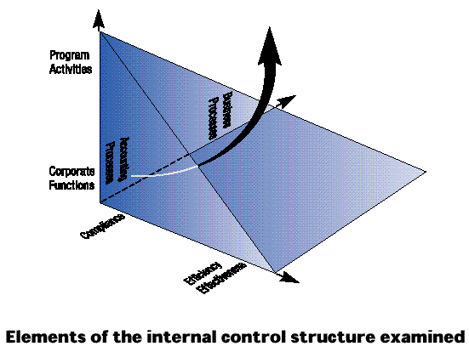
Three dimensions for viewing the internal audit function create a large number of available permutations of areas for internal audit activity.
Recent trends reflect a move away from the ‘traditional’ narrow, assurance focus toward a broader, whole of business, support and advising perspective.
Elements of the internal control structure examined
The internal control structure may be understood in terms of five inter-related elements viz., the control environment; risk management; control activities; information and communication; and monitoring and review.
The examination and evaluation of the adequacy and effectiveness of internal control is generally considered to be a primary responsibility of internal audit. In fact, the internal audit function itself, forms part of the internal control structure of an organisation.
Internal audit reviews may encompass any, or all, of the components of the internal control structure. However, the traditional emphasis has been on control activities, possibly complemented by consideration of elements of the control environment.
Internal audit has generally been less inclined to consider and evaluate higher level management controls associated with the information and communication, and the monitoring and review elements of the internal control structure; nor have they generally played a significant role in evaluation of the processes for the identification and evaluation of business risks.
Nature of internal audit activity
The final point to consider when establishing a role for internal audit is the nature of the work it undertakes. This may range from transactions-based, detailed testing to process-based, review and observation.
Detailed testing is characterised by the audit of past transactions and events. The emphasis is on obtaining and inspecting documentary evidence in order to substantiate the validity and/or the completeness and accuracy of the data in the records of the organisation that is associated with the transactions and events.
Internal audit is taking a broader perspective of its activities, moving away from substantiating transaction flows, to analysing process flows. This approach has its basis not in direct examination of transactions but in documentation, understanding and evaluation of the business processes and events which generate the transactions. Internal audit is also moving outside its traditional audit 'assurance' role to one of facilitation and advice, predicated on its greater understanding of business processes and the business acumen and insights of internal audit staff.
The latter role may include participation in the design and development stages of projects, including providing advice on appropriate internal controls. It can also encompass decision-support activities, such as 'probity' reviews of processes (eg tender processes) before decisions are made.
To find the best fit internal audit must be aware of, and responsive to, changing organisational needs. The chief executive, in seeking to improve the internal control structure, may use internal audit predominantly in an assurance role.
As the control structure improves, greater emphasis may be given to a pro-active, business advising and decision-support role.
The table opposite aligns the organisational context with appropriate roles for internal audit. It is based on the principle that the state of internal control of an organisation is a key determinant of the most cost-effective role for internal audit.
Finding the best fit
Deciding on the appropriate role for internal audit is a question of establishing where it can add most-value given the particular circumstances of an organisation.
The traditional compliance-based, assurance role is as valid and appropriate for a given set of circumstances as is the trend toward a forward looking, decision-support role. It is most often a question of achieving the correct balance between the two extremes.
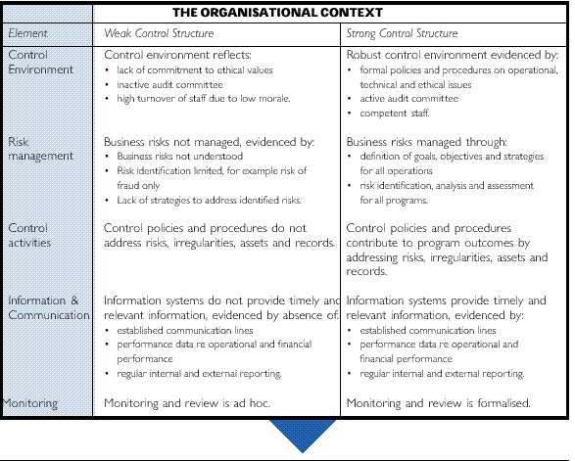
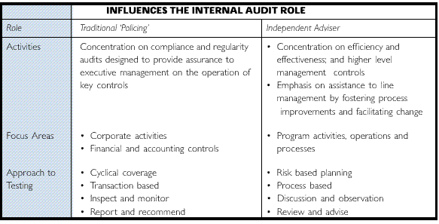
Establish the audit program
Having determined the role (or roles) that are appropriate for the internal audit function, it is necessary to establish a program of desired and accepted coverage.
Internal audit should prioritise its activities based on agreed assessments and ranking of business risks.
In practice, such a program will be developed by internal audit, after consultation with executive and senior management (including the audit committee), and submitted to the chief executive for approval.
The traditional approach to planning involves defining an audit 'universe' of the functions, activities and processes from which to select possible audit topics. The selection of topics is undertaken to achieve coverage of the universe over a given period of time. The usual cycle is programmed to be completed over a three year period.
Today it is recognised that a purely 'cyclical' approach to determining internal audit coverage is unlikely to be as effective as one predicated on identification of risks and the prioritisation of internal audit activity based on an assessment of these risks.
It is worth restating, as discussed in the previous Part of this Guide, that the analysis of risk should take account of all significant risks to the achievement of corporate objectives. This holistic, business-oriented risk approach should ensure internal audit coverage focuses on those functions, processes and activities which have attached to them the greatest risk of failure or loss, or where the potential for process improvement will add greatest value.
In order to undertake an effective risk assessment an appropriate business risk analysis model is required. The model used will ideally provide a structured, systematic mechanism for:
* identifying risks;
* determining the consequences arising from the risks;
* considering the likelihood of their occurrence; and
* determining the overall significance (or level) of each risk.
The risk analysis model should also take account of the impact of the internal control structure on identified risks.
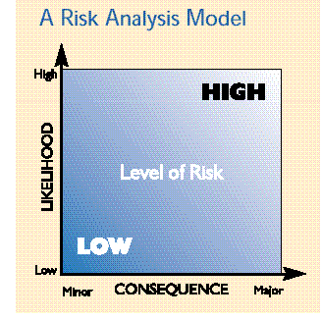
The design, implementation and operation of internal management and accounting controls is directed to reducing risk to an acceptable level.
While of themselves, particular risks may be considered to be high, once the operation of the internal control structure is taken into account the residual risk may be quite low. The important question (for management) is whether the level of residual risk is tolerable.
Internal audit will prioritise its planned activities, based on its assessment of the level of risk, both before and after the operation of the internal control structure is considered. This will enable it to develop a ranking against which to schedule coverage of business critical areas of the organisation. It will also assist in determining the extent and nature of internal audit coverage required in these areas.
In the latter sense, the role of internal audit is closely linked to the nature and level of business risks facing the organisation. The use of systematic risk analysis is an essential overlay to the decisions made on the most appropriate role for internal audit, discussed previously.
The risk analysis and ranking, while undertaken independently by internal audit, should be discussed and agreed both with executive management (including the audit committee) and with senior line management.
Indeed it is management's role to undertake risk analysis and to design systems and controls which manage these risks. The independent appraisal undertaken by internal audit for its own planning should not be a surrogate, but should be complementary to management's assessment.
“Business risks might include:
• failure of a project to meet its objectives;
• client dissatisfaction;
• unfavourable publicity;
• threat to physical safety;
• breach of security;
• mismanagement;
• failure of equipment or computer systems;
• breach of legal or contractual responsibility;
• fraud; and
• deficiencies in financial controls and reporting”.
MAB, Risk Management, 1996
Obtain resources
When making resource decisions in relation to internal audit the underlying objective is to achieve an appropriate balance of skills, knowledge and background to enable delivery of an integrated, cost-effective internal audit function.
The role mapped out for internal audit—its business risk focus, the nature of work undertaken, and the subject matter of its activities—will determine the level and type of resources required.
As internal audit takes a broader approach to the identification and assessment of business risks; involves itself in the audit of operational areas; and moves away from its financial and compliance focus; the knowledge, skills and competencies required to effectively fulfil these roles will vary significantly from those traditionally associated with the internal audit function.
Whatever role is determined for internal audit and whatever staff profile is therefore appropriate, the challenge has always been to find and retain the 'right' people.
From a practical perspective this challenge may be met through one of three resourcing strategies:
* wholly in-house;
* wholly out-sourced; or
* a mix of the above (co-sourced).
Which arrangement is appropriate will depend on the particular circumstances of an organisation. Each has its benefits and its challenges.
The size of the organisation will generally influence the size of the internal function. In turn, size can be a significant factor in determining the viability of an ‘in-house’ solution.
The ‘In-House’ Solution
This strategy assumes that the competencies required for the internal audit function will be obtained through recruitment and retained within the organisation for as long as they are required. The major risk associated with this strategy relates to a lack of flexibility in the short to medium term. An organisation needs to be able to react quickly to external and internal changes which impact the role for internal audit, and therefore the competencies required, if it is to maximise the value obtained from internal audit.
As the skill and knowledge profiles for internal auditors change it will be necessary to either invest in training and retraining of existing staff, or to obtain new staff with the competencies required. Both approaches will be costly-the latter creating an additional issue of what to do with existing internal audit staff who no longer possess the skills and knowledge required.
Maintaining an 'in-house' internal audit function also has associated with it the practical issue of identifying, attracting and retaining recruits to replace staff who leave through natural attrition.
A survey carried out by the ANAO suggested an average 'life' for an internal audit employee to be four years and turnover rates to be as high as 33 per cent.
Another difficulty particularly facing 'small' internal audit units is the reduced capacity to cover all the competencies required with a small number of staff.
The risk associated with these practical difficulties is that the existing staff profile will drive the role of internal audit rather than the organisational context and the needs of management.
This can seriously affect management's view of the value of internal audit and is, consequently, one of the major factors in decisions taken to out-source the function.
Many of the benefits of an 'in-house' strategy relate to less quantifiable factors such as the internal auditor's knowledge of organisational methods, accessibility, responsiveness, loyalty, and a shared vision for organisational success.
In our research some organisations expressed a clear preference for retaining an 'in-house' internal audit function because of the central importance of its role in corporate governance.
Only one quarter of surveyed organisations maintain a wholly in-house internal audit function.
In these organisations there was strong management support for, and commitment to, the internal audit function. Internal audit had responded by adopting a proactive, client-focused approach which sought to meet the needs of both executive and line management.
Common approaches adopted in these organisations, to overcome the risks discussed above, include:
* executive management (generally represented by the audit committee) take a close interest both in setting the academic and competency standards for the internal audit function, and in monitoring the actual staff profile against these standards;
* staff recruited have varied backgrounds and competencies, rather than relying solely on traditional auditing and accounting skill sets;
* suff icient resources and support are provided to ensure internal audit staff undertake continuing professional development; and
* career paths have been created that either stem from internal audit or include a secondment to internal audit.
The benefits of these approaches are that they identify internal audit as a prestigious and valued area within the organisation that provides excellent career opportunities. As a result highly skilled, motivated professionals are attracted to the function. When they move from internal audit they are more likely to remain with the organisation and have a much greater understanding of the entire organisation. They can be generally better managers as a result of this exposure.
The ‘Out-Sourced’ Solution
In a U.S. study carried out in 1996³ the three reasons most cited for out-sourcing all or part of the internal audit function were: to provide budget savings (60 per cent); to improve the product by contracting for audit skills not available internally (17 per cent); and to 'clean house' of incompetent people or those perceived not to be adding value (10 per cent).
In the ANAO 1997 internal audit survey of 50 organisations, 35 per cent indicated they fully out-sourced their internal audit function. There is some evidence to suggest that out-sourcing internal audit can result in cost-savings. In the Financial Control and Administration audit undertaken in 1997⁴ it was observed that the average cost of internal audit was lower under out-sourced arrangements. However no data was available on whether the cost savings achieved also correlated with a reduction in coverage or limitation of scope of the internal audit function.
Audit Directors and professional bodies have expressed concern that out-sourcing can be used in this way to disguise a downgrading of the internal function. The systematic approach outlined in this guide to establishing internal audit resource requirements based on organisational context, a clearly defined role and agreed internal audit program of coverage, should allay such concerns. While cost will be a factor in an out-sourcing decision, thought need also be given to quality considerations. In many small organisations, with internal audit units of a commensurate size, it will be difficult both to attract staff with the requisite skill sets and, as discussed previously, to find within a small number of staff the full range of skills required.
Small internal audit units find it difficult to undertake integrated audits, using mutli-disciplinary teams, with a resultant loss of effectiveness and/or eff iciency.
They generally also find it more difficult to be responsive to line man- agement needs and will generally focus on their assurance role to meet executive management needs.
They also generally offer limited career paths both within internal audit and within the organisation. The organisation has a limited capacity to support development opportunities, such as secondments or transfers, and limited funds to support ongoing professional development activities.
These are all issues revolving around what is often referred to as the 'critical mass' of the internal audit unit.
In such organisations full out-sourcing is considered to be a viable, practical solution. It provides access to a large pool of skilled resources with varied expertise. As such, it allows an organisation to more readily align its internal audit resources to its operations and to its business risks.
The significant risk associated with full out-sourcing relates to the qualitative factors referred to previously. Whether contracted staff, who may vary depending on the individual assignment, will be able to gain a suff icient exposure to, and understanding of the operations they are reviewing or an adequate appreciation of management approaches and styles, are real issues in terms of the effectiveness of the audit product.
This risk increases in direct proportion to the size of the organisation, the complexity of operations and the breadth of internal audit activity.
A related risk relates to the capacity of an organisation to effectively manage the internal audit contract. Organisations can face the dilemma of having no 'in-house' expertise to be able to critically evaluate the ongoing effectiveness and value obtained under the contract.
In these cases the role of the audit committee in evaluating internal audit performance assumes even greater importance.
The ‘Co-Source’ Solution
The use of a core of 'in-house' internal audit staff, supplemented as required, by contracted-in expertise is an effective compromise to the risks and benefits associated with the first two resource strategies.
It achieves a 'best of both worlds' outcome and as such reduces or eliminates many of the risks discussed previously while retaining most of the benefits.
Having in-house staff provides for greater 'corporate' knowledge and understanding; loyalty and commitment; and accessibility. Using contractors on specific assignments provides access to a larger, more diverse resource pool and permits internal audit to undertake a broader role. It also provides greater flexibility for internal audit to vary its role over time, to keep in step with changing organisation and management needs.
Co-sourcing also permits the formation of multi-disciplinary teams with the added benefit of providing skills and knowledge transfer between the contracted 'experts' and in-house staff. If the contracted-in resources are obtained from a single source, such as an accounting firm, the organisation may also be able to use its leverage from the contract to develop 'in-house' staff through short-term secondments to the firm and through participation in the firm's own professional development activities. Where co-sourcing is used, it is observed that the key position of head of internal audit is usually retained 'in-house'.
The profiles and development of 'in-house' staff generally align with those activities that will be subject to regular internal audit review. In one organisation the 'in-house' staff focused on the 'traditional' assurance role in regard to the financial and accounting controls, while the contracted-in staff were used more as operational 'consultants'.
Which solution is right for your organisation?
In choosing the appropriate resource strategy for your organisation the following factors may be considered.
Organisation:
* scope for use of 'parent' organisation's internal audit resources
* size of organisation
* current role of internal audit compared with desired role
* actual size of internal audit unit compared with desired size
Value for money:
* average annual cost of function per full time equivalent audit resource
* total annual cost of function
Staff profile:
* average annual turnover of in-house staff compared with degree, or likelihood, of continuity of contracted staff
* per cent of 'in-house' staff retained within organisation after leaving internal audit
* actual competencies compared with required competencies
* average annual training hours provided compared with hours required
Performance improvement cycle:
* re-engineer 'in-house' processes
* competitive tendering and contracting
* potential to innovate and improve performance
* potential for conflicts of interest
* ability to effectively manage and monitor contractor performance.
Embed review mechanisms
After the role for internal audit has been defined, the program of coverage determined, and the appropriate resources secured, it is necessary to ‘build-in’ monitoring and review mechanisms which provide information for assessing the continued effectiveness of the function.
The ANAO benchmarking study of Commonwealth internal audit units, and the Institute of Internal Auditors GAIN database, are useful sources of metrics for benchmarking.
Such information is important, not just from an accountability viewpoint, but also from the perspective of continuous improvement discussed in Part One of the guide. In this regard, the information obtained to measure effectiveness should also be able to signal where improvements may be required.
In order to fulfil both purposes, reports on performance could incorporate external benchmarks (or metrics) for comparison. These benchmarks should deal both with internal audit processes and with internal audit outputs (products and services).
Appropriate metrics can be built into a 'scorecard' approach which aligns performance ratings with achievement against the metrics. For example, results which correspond with the top ten percentile of a benchmark group would be scored higher than results which fall into a lower percentile.
Achieving an appropriate balance is necessary for credible and useful performance measurement and therefore reports on performance should also include qualitative indicators to supplement the quantitative metrics.
The Toolkit includes two approaches to the balanced reporting of performance information.
The frequency of review of performance and the recipients of reports on performance are also important considerations when establishing monitoring mechanisms.
The concept of continuous improvement suggests that, at least within internal audit, there should be ongoing monitoring of performance.
As most internal audit activity is undertaken on a project basis it would be appropriate to conduct some form of review at the end of each project.
This review can be used to capture the performance information required for input into the annual review of the function. It can also be used to examine the audit from a process and outcome perspective and consider what areas could have been improved. Some of the data obtained at this review stage could be incorpo- rated as an appendix into the final report provided to the audit 'client' as a means of making the internal audit process more transparent to its customers and discharging accountability to these stakeholders.
At this level of reporting, and given the short time-frames involved, quantitative data on the timeliness, cost and quality of internal audit activity would be appropriate.
Given the effort involved and their nature, more detailed, comprehensive reports, dealing with overall outcomes, would be provided less frequently.
In our Better Practice Guide on Audit Committees it was recommended the audit committee formally review and report on the effectiveness of the internal audit function at least annually.
To assist in the audit committee meeting its own responsibilities it would be appropriate for the internal audit unit to provide up to date performance information at each committee meeting.
Toolkit
1. Model internal audit charter
2. Internal audit diagnostic questionnaire
3. Sample client survey
4. Quantitative benchmarks
1. Model internal audit charter
OBJECTIVE
This Internal Audit Charter has been developed to provide a broad framework, professional standards and guidelines for the conduct of Internal Audit.
The Internal Audit Charter is subject to review as needs arise to ensure an appropriate level of cost effective value added service and has been approved by the Audit Committee and CEO.
INTRODUCTION TO INTERNAL AUDIT
The primary purpose of Internal Audit is to provide a comprehensive value added internal audit service to management. Internal Audit provides analysis, appraisals, and recommendations on the operations reviewed. This is achieved by examining and evaluating the adequacy, effectiveness and eff iciency of systems of internal control and the quality of management in an independent and professional manner.
Internal Audit should not develop or install procedures or systems, prepare records, or be engaged in original line processing functions. This does not exclude auditors from suggesting system development projects or being consulted on existing systems. Post-implementation reviews shall be conducted by Internal Audit of all systems developed for use by the Organisation, in order to evaluate the adequacy and effectiveness of internal controls, where considered appropriate.
A review or appraisal by Internal Audit does not in any way relieve Organisation officers of their individual responsibilities.
INDEPENDENCE
The Chief Internal Auditor is authorised to direct a broad, comprehensive program of internal auditing within the Organisation. The Chief Internal Auditor, and members of the audit staff are authorised to have full, free and unrestricted access to all functions, property, personnel, records, accounts, files and other documentation. Information accessed in the course of audits is to be used strictly for audit purposes.
AUTHORITY
Independence is essential to the effectiveness of internal auditing. This independence is obtained primarily through organisational status and objectivity.
The Chief Internal Auditor is functionally responsible to the Audit Committee to ensure not only the broadest range of audit coverage but adequate consideration of audit reports and appropriate action on audit recommendations.
Internal Auditors should be independent of the activities they audit. Internal auditors will report to the Chief Internal Auditor any situations in which a conflict of interest or bias is present or may be reasonably inferred. Internal auditors should not assume operating responsibilities.
RESPONSIBILITY
The Chief Internal Auditor is responsible to the Audit Committee in relation to all internal auditing and fraud and corruption matters. The Chief Internal Auditor will have unfettered access to the CEO and the Audit Committee and is responsible for the management of Internal Audit .
The Chief Internal Auditor will report to the Audit Committee on the performance of the Internal Audit function against the key performance indicators agreed with the Audit Committee (see Attachment A).
STANDARDS
Internal Audit shall comply with the following:
* Standards for the Professional Practice of Internal Auditing issued by the Institute of Internal Auditors;
* Statement on Information Systems Auditing Standards issued by the Information Systems and Control Association; and
* Audit Practice Statements as appropriate to internal auditing of the Australian Society of Certified Practising Accountants and the Institute of Chartered Accountants in Australia.
Internal auditors are required:
* to comply with professional standards of conduct;
* to possess the knowledge, skills, and technical proficiency essential to the performance of internal audits;
* to be skilled in dealing with people and in communicating audit issues effectively;
* to maintain their technical competence through a program of continuing education; and
* to exercise due professional care in performing internal audits.
AUDIT PLAN
A Strategic Audit Plan shall be prepared for approval by the Audit Committee and reviewed each year, showing the areas proposed for review during the forthcoming year. The Plan shall be based on an assessment of the organisation's business risks.
The annual Strategic Plan and the actual audit performance shall be regularly reviewed by the Audit Committee. Any necessary amendments to the plan shall be submitted to the Audit Committee for consideration and approval.
SCOPE AND FREQUENCY OF AUDIT
The scope of Internal Audit encompasses the examination and evaluation of the adequacy, effectiveness and eff iciency of the system of internal control and management performance. Internal Audit review covers all activities of the Organisation together with associated organisations and their commercial activities. It involves the review of all financial and non financial operations, either manual or computerised. Internal Audit review also extends to management information systems.
AUDIT TECHNIQUE
Internal Audit shall use the most appropriate auditing methodology for each audit depending on the nature of the audit and the predetermined parameters.
AUDIT REPORT
On conclusion of the audit, a copy of the report on the audit outcome shall be issued to the client and to the CEO and shall be tabled at the next meeting of the Audit Committee.
The report shall present the audit objectives, scope, the audit opinion based on the outcome of the audit and an agreed implementation timetable for audit recommendations.
Internal Audit reports will not be finalised until management agreement to the implementation timetable for remedial action has been obtained.
QUARTERLY REPORT
As soon as practicable after the end of each quarter, the Chief Internal Auditor, shall submit to the Audit Committee a report summarising all audit activities undertaken during that quarter and performance against the agreed key performance indicators.
This report shall indicate:
* assignments completed or in progress;
* outcomes of each assignment undertaken; and
* remedial action taken.
QUALITY ASSURANCE PROGRAM
The Chief Internal Auditor shall establish and maintain a quality assurance program to evaluate the operations of Internal Audit. The program will incorporate benchmarking and peer review of the function.
The purpose of this program is to provide assurance that audit work conforms with the Standards for the Professional Practice of Internal Auditing, the Internal Audit Charter, and is both cost effective and efficient.
LIAISON WITH EXTERNAL AUDITORS
Internal and external audit activities should be coordinated to ensure adequate audit coverage and to minimise duplication of effort.
Periodic meetings between internal and external audit shall be held to discuss matters of mutual interest.
Access to Internal Audit programs, working papers and reports shall be made available for review by external auditors.
KEY PERFORMANCE INDICATORS
Attachment To Charter
In relation to the Organisation, auditing which:
* produces major impacts on the critical success factors of the Organisation and management success;
* adds value and timeliness to the management process;
* contributes to major management decisions and business improvement and provides improvement to service to external customers; and
* facilitates the promulgation of best practice activities by management, for example control self assessment tools.
A profile and relationship which results in Internal Audit being sought and used as a special service (consultative) and a sounding board as well as initiating audits itself.
In relation to Internal Audit's own performance:
* measurement of progress against the approved Strategic Audit Plan;
* extent of staff development and interchange with other areas of the Organisation;
* measurement of productivity by recording and comparing actual person days expended against the budgeted number of days for each item of the Plan;
* finalise all audit reports within one month of completing field work;
* survey management to ascertain customer satisfaction; and
* peer review and benchmark activities against similar operations.
2. Diagnostics
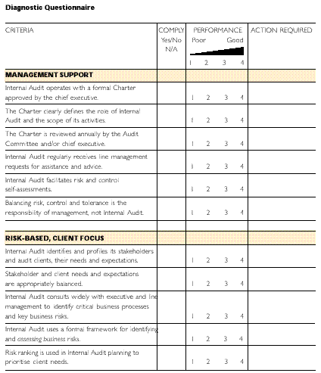
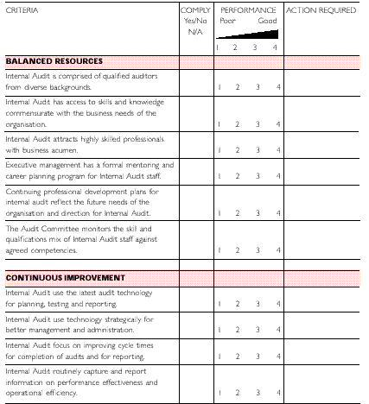
3. Sample client survey
Client surveys are an effective feedback mechanism which can provide both quantitative and qualitative data on performance. In developing and agreeing the format, structure and content of a client survey it is important to focus on the information needs of internal audit.
Client surveys can be conducted formally or informally. They can be undertaken using focus or discussion groups, through questionnaires or even through e-mail or hotlines established to collect client comments.
One approach used by a number of private and public sector internal audit units is a formal client survey questionnaire. Generally this is used at the conclusion of an audit assignment to assess performance against that task.
Questionnaires should be as brief as possible to allow completion in an acceptable time frame. To facilitate comparability they should include an evaluation scale which is numbered. They may also include consider points for subjective questions to ensure consistency of interpretation and evaluation.
The probability of receiving a timely response can be enhanced by addressing the questionnaire to a particular person with a covering note from the head of internal audit or the Chair of the audit committee.
The client survey questionnaire can be structured to obtain measures of performance effectiveness in a number of ways, including:
* key performance indicators;
* a balanced score card;
* the principles in this guide; and
* Corporate goals and objectives.
The following sample questionnaire has been developed in line with the principles used in this guide. It provides some examples of the types of questions that can assist in obtaining feedback from clients.
Client Survey (Example Only)
The following questionnaire will assist in identifying areas where improvements in performance can be made to provide a better Internal Audit service to the Organisation.
Would you please assess the performance of Internal Audit under each of the key result areas and, in particular, provide examples or more detailed comments against those consider points where performance was ranked below 3.
[signed]
Chair
Audit Committee
Audit Name: _____________________
Date Started: ____/____/____
Date Completed: ____/____/____
Auditors Involved:
______________________ Manager
______________________ Team
Client Name: ______________________
Business Unit: ______________________
Contact Details: ______________________
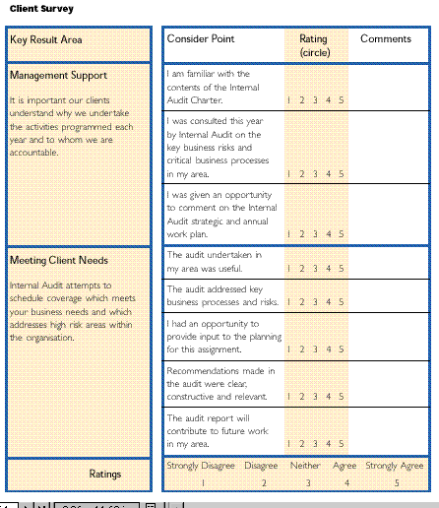
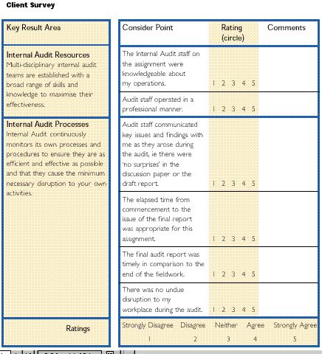
Thank you for taking the time to complete this questionnaire. Your responses will be used both as part of Internal Audit's performance indicators and to improve our processes. Please attach any additional comments relevant to these purposes that you believe have not been adequately dealt with in the questionnaire.
4. Quantitative benchmarks
The use of performance indicators is an effective means by which to measure and report on internal audit performance.
When utilised in conjunction with appropriate benchmarks they can also highlight areas where improvements are required.
While some indicators readily lend themselves to external comparison and therefore the use of external benchmarks, others will require internally generated benchmarks.
In this respect past experience can be a useful starting point from which to develop future 'stretch' targets.
Whatever targets are set, they should be set in consultation with the audit committee and the chief executive.
The following tables provide a range of possible performance indicators (and external benchmarks where available) that may be used to evaluate internal audit effectiveness.
The benchmarks have been derived from the results of the 1997 ANAO survey of internal audit in the Commonwealth.
'Common' practice generally represents the average result for the surveyed group. 'Best' practice generally reflects the average from the top ten percentile of the surveyed group.
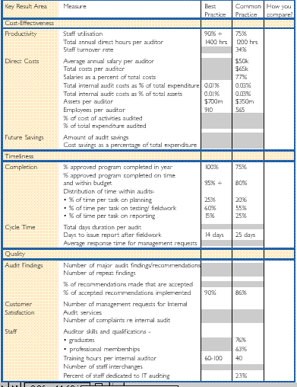
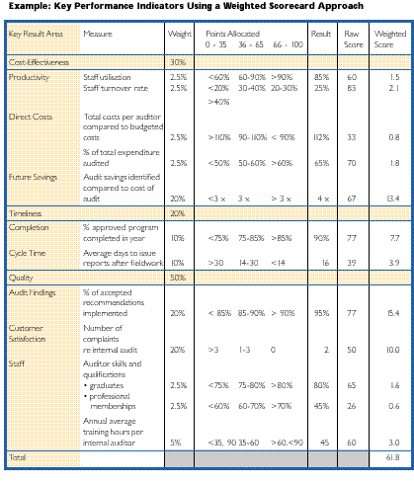
NOTES:
(a) Measures, weights, and point allocations need to be considered on a case-by-case basis to reflect the requirements of users, particularly the audit committee. The pattern of measures, weights and allocations needs to be adjusted to focus attention on those aspects of the Internal Audit function according to the priorities of the audit committee and other users.
(b) An overall points score of 50 translates to an internal audit unit operating at common practice.
(c) Points are allocated on a numerical scale such that 0 represents the minimum, and 100 the maximum score possible for each attribute.
Better practice in practice
A NEW FOCUS FOR INTERNAL AUDIT
Relationship with Executive Management and the Audit Subcommittee
An organisation in the communications industry was reviewed to see how the relationship between internal audit and its clients had been developed.
The Mission of internal audit in this organisation is:
'to provide the Board and senior management and other key customers with a high quality, cost effective and value added service, with focus on assisting management in the achievement of the goals and objectives of the organisation in the Corporate Plan.'
With this mission as its guide the internal audit function has moved beyond traditional internal audit practices.
The head of internal audit has a strong consultative relationship with both the audit committee and executive management. The Chief Internal Auditor meets regularly, formally and informally, with the Chair of the audit committee and the CEO. He has full and free access to all members of the committee and the Executive, formalised in an authoritative Internal Audit Charter.
Regular consultation and a focus that addresses the needs and concerns of management, coupled with a professional audit approach has led to a high level of respect and trust within executive management for the work of internal audit. They are called upon to advise management on issues of concern and have significant direct input to audit subcommittee meetings and decision making.
The Chief Internal Auditor has been instrumental in developing a close working relationship with line management, in building a highly skilled and qualified team, and adopting a consultative client focus.
His vision was to move internal audit from a financial compliance role to a value-added 'business consulting' role. Working with management, and using regular meetings to continually assess the effectiveness of internal audit work, has led to the development of an audit product that has become part of the organisation's improvement processes.
The ANAO visited a multinational Insurance Company that had opted for an alternative to internal audit.
Do we need internal audit?
The key driver for this approach was the prevalent attitude amongst line management that internal audit was responsible for the internal control structure.
The organisation implemented a governance model, based on risk management principles, which incorporated the internal control structure as a key result area, and the effective management of risks as a critical success factor, in the annual operational plans of all senior line managers.
The principles of risk and control self-assessment were used to require line management to identify and assess risks and to identify and assess the effectiveness of controls.
Underpinning this approach was an proprietary database developed to capture the results of the self-assessment exercises and to report on progress against the key result areas and critical success factors in the operational plans. The database is updated monthly by line managers.
This approach places responsibility for the management of risks squarely on the shoulders of line managers. The organisation took the strategic decision to dispense with the internal audit unit altogether.
Using a ‘change agent’ to refocus Internal Audit
ANAO also visited a large finance company, which re-evaluated the nature and focus of the internal audit unit.
In response to line management dissatisfaction with the relevance and cost-effectiveness of internal audit, executive management stepped in to re-engineer the function.
The key step in this process was a review of the position, qualifications, skills and experience of the Chief Internal Auditor. The result was a change in the head of internal audit. The replacement had a strong background and grounding in auditing. The new head was employed for a fixed term contract and given this time to effect the necessary changes.
The result was the transformation of the internal audit function into a operational consulting role, working in partnership with line management to help achieve the organisation's objectives.
FOOTNOTES
¹ A detailed exposition of the internal control structure is provided in the ANAO publication ''Control Structures in the Commonwealth Public Sector - Controlling Performance and Outcomes'.
² The ANAO publication, Control Structures in the Commonwealth Public Sector - Controlling Performance and Outcomes' contains detailed checklists which can be used for this purpose.
³ Kusel J., Schull R., Oxner T, 'What Audit Directors Disclose About Outsourcing', Institute of Internal Auditors, 1996.
⁴ 'Internal Audit', Audit Report No. 46, 1997-98

© Commonwealth of Australia 2000 | Contact Us | Disclaimer | Privacy
This page was last modified 07/23/2002 04:10:08 PM

